Asini Corii Colla exhibits anti-photoaging efficacy via activating collagen synthesis and maintaining redox & extracellular matrix homeostasis

Xiao Xie^{1,#}, Zhijie Chen^{1,#}, Zesong Zhang^{2,#}, Zailin Chen^{2,#}, Cong Li¹, Jianling Zhang¹, Jiahao Yang³, Zhihui Lu⁴, Lei Jia³, Meimei Fu^{5,}*, Jinshan Guo^{3,5,}*

¹Liaocheng Key Laboratory of Functional Food Research and Development, Liaocheng Engineering Research Center for Nutrition and Health Consumer Products, Dong'e Ejiao Health Industry Technology Co., Ltd., Liaocheng, 252201, P. R. China.

²Department of Endocrinology, Department of Preventive Medicine, Dongguan Qingxi Hospital, Xiangmang Middle Road, Qingxi Town, Dongguan, 523660, P. R. China

³Biomaterials and Stem Cell Research Laboratory, Suzhou Institute of Biomedical Engineering and Technology, Chinese Academy of Science, Suzhou, 215011 P. R. China

⁴Regenerative Medicine and Tissue Repair Research Center, Huangpu Institute of Materials, 88 Yonglong Avenue of Xinlong Town, Huangpu District, Guangzhou, 511363, P. R. China

⁵Department of Histology and Embryology, NMPA Key Laboratory for Safety Evaluation of Cosmetics, GDMPA Key Laboratory of Key Technologies for Cosmetics Safety and Efficacy, School of Basic Medical Sciences, Southern Medical University, 1023 Shatai Rd., Guangzhou, 510515, P. R. China.

#These authors contribute equally.
*Corresponding authors: jsguo4127@smu.edu.cn, guojinshan@sibet.ac.cn (J. Guo), fmm05037726@163.com (M. Fu).

Fig. S1. Standard curve of the BCA protein assay for sample protein determination.

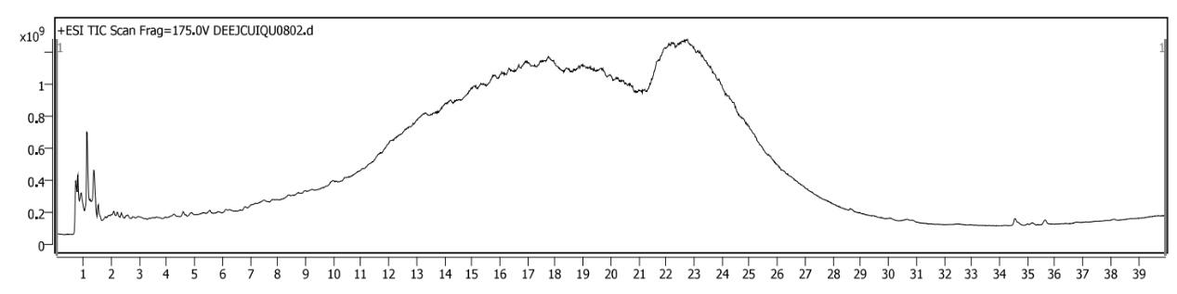
Fig. S2. Total ion current chromatogram of the LC-MS/MS analysis of the enzymatically digested ACO sample.

Fig. S3. LC‑MS/MS identification chromatograms of 17 amino acids in the ACO sample.

Fig. S4. LC-MS/MS spectra for identification of donkey-derived signature peptides A1 and A2. (A) MRM chromatograms of peptides A1 and A2; (B) full-scan MS and MS/MS spectra of peptide A1; (C) full-scan MS and MS/MS spectra of peptide A2.

Table S1 Seventeen amino acids identified in the ACO sample.
Name | Formula | RT | Mass | CAS | Score
Dehydroamino-x-butyric acid | C₄H₇NO₂ | 1.131 | 101.0476 |  | 96.01
Hydroxyproline | C₅H₉NO₃ | 0.798 | 131.0583 | 6912-67-0 | 99.76
Glycine | C₂H₅NO₂ | 0.798 | 75.0320 | 56-40-6 | 86.71
Proline | C₅H₉NO₂ | 2.610 | 115.0634 | 147-85-3 | 99.97
D-Phenylalanine | C₉H₁₁NO₂ | 2.360 | 165.0790 | 673-06-3 | 99.77
D-Cysteine | C₃H₇NO₂S | 5.534 | 121.0186 | 921-01-7 | 69.49
D-Glutamate | C₅H₉NO₄ | 0.798 | 147.0533 | 6893-26-1 | 92.03
Valine | C₅H₁₁NO₂ | 0.881 | 117.0790 | 516-06-3 | 99.04
L-Histidine | C₆H₉N₃O₂ | 0.915 | 155.0694 | 71-00-1 | 86.59
L-Norleucine | C₆H₁₃NO₂ | 1.496 | 131.0946 | 327-57-1 | 99.88
DL-Serine | C₃H₇NO₃ | 0.798 | 105.0426 | 302-84-1 | 99.31
D-Aspartic acid | C₄H₇NO₄ | 0.798 | 133.0375 | 1783-96-6 | 99.65
2-Piperidinecarboxylate acid | C₆H₁₁NO₂ | 0.732 | 129.0791 | 535-75-1 | 87.29
Pyroglutamic acid | C₅H₇NO₃ | 0.798 | 129.0427 | 98-79-3 | 99.12
DL-Tryptophan | C₁₁H₁₂N₂O₂ | 4.338 | 204.0898 | 54-12-6 | 86.43
L-Arginine | C₆H₁₄N₄O₂ | 0.748 | 174.1121 | 74-79-3 | 98.38
Hydroxylysine | C₆H₁₄N₂O₃ | 1.131 | 162.1018 | 13204-98-3 | 99.70

Table S2 Mass spectrometric identification parameters of donkey-derived signature peptides A1 and A2.
Name | Formula | RT | Mass
Peptides A1 | C₄₁H₆₈N₁₂O₁₃ | 19.326 | 936.5062
Peptides A2 | C₅₁H₈₂N₁₈O₁₈ | 22.616 | 1234.5989

